A logical network diagram describes the way information flows through a network. Therefore, logical network diagrams typically , network devices like routers,server and firewalls.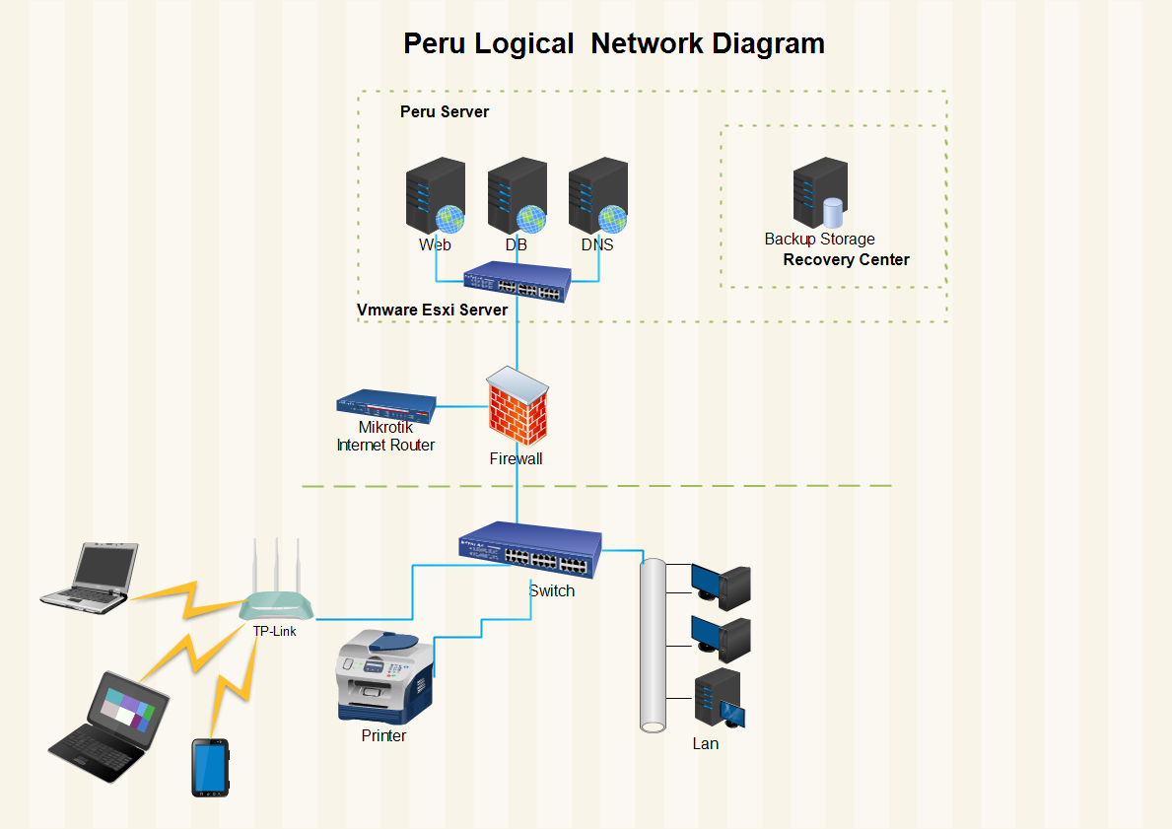

**Physical network diagram**

A physical network diagram shows the actual physical arrangement of the components that make up the network, including cables,Pvc Ducts,Connectors. Typically, the diagram gives a over view of the network in its physical space of NMFA office.

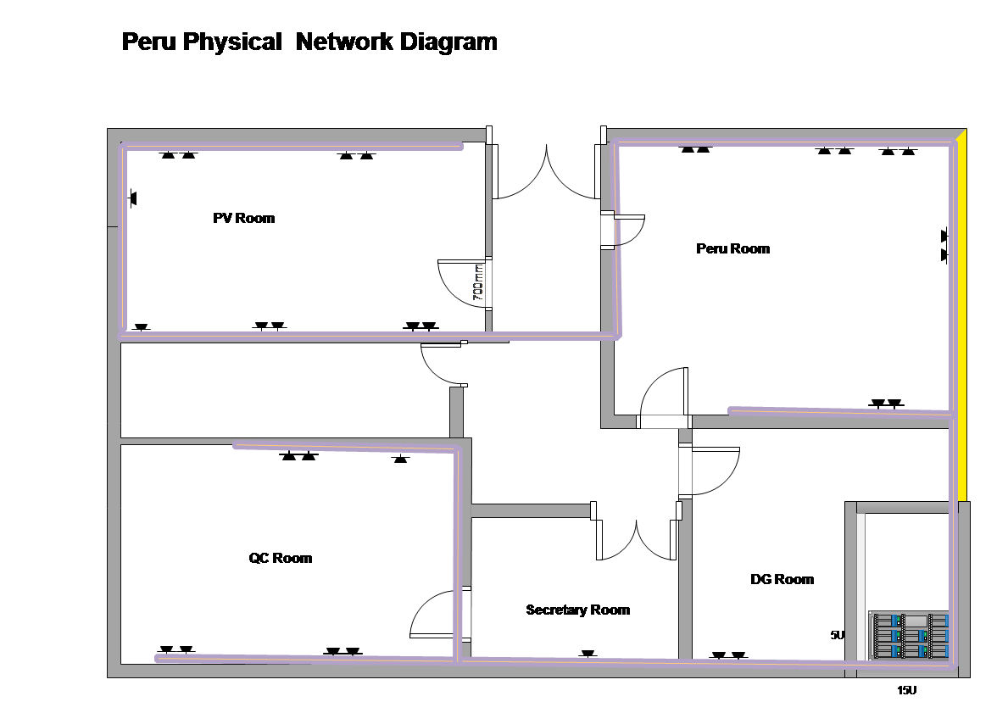

**VMware ESXi**

VMware ESXi is an enterprise-class, type-1 hypervisor developed by VMware for deploying and serving virtual computers. As a type-1 hypervisor, ESXi is not a software application that is installed on an operating system; instead, it includes and integrates vital OS components, such as a kernel.

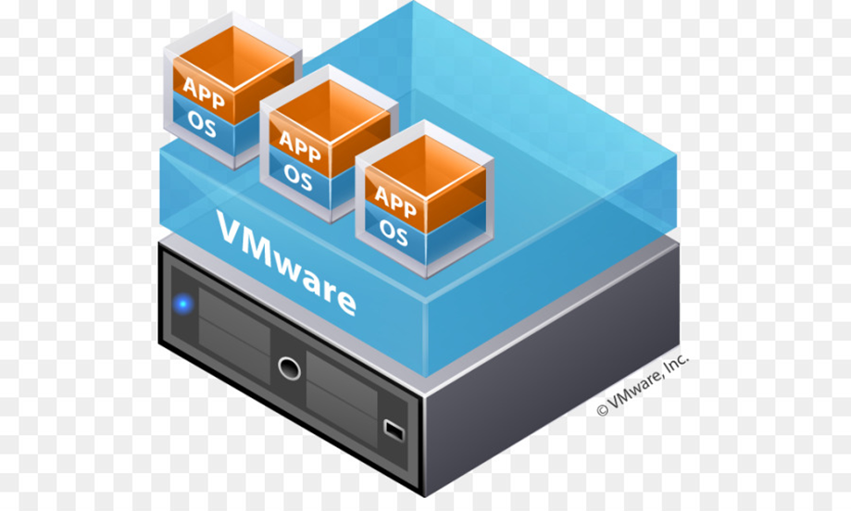

VMware ESXi 7.0, bare-metal hypervisor that installs directly onto physical server (Dell Server). With direct access to and control of underlying resources, VMware ESXi effectively partitions hardware to consolidate applications and cut costs. It’s the industry leader for efficient architecture, setting the standard for reliability, performance, and support.

**Ubuntu 21.04 OS**

Ubuntu is a Linux distribution based on Debian and composed mostly of free and open-source software.Ubuntu 21.04 is installed on Vmware Esxi as a virtual Machine.

Nginx

Ngnix is a web server that can also be used as a reverse proxy, load balancer, mail proxy and HTTP cache. Nginx is built to offer low memory usage and high concurrency. Rather than creating new processes for each web request, Nginx uses an asynchronous, event-driven approach where requests are handled in a single thread.it is popular  due to its light-weight resource utilization and its ability to scale easily on minimal hardware

NGINX performs 2.5 times faster than Apache according to a benchmark test performed by running up to 1,000 simultaneous connections. Another benchmark running with 512 simultaneous connections, showed that NGINX is about twice as fast and consumed less memory.that why ngnix iscurrentlythe web server that powers more than 400 million websites

**MySQL Server** 8.0.28

MySQL is an open-source relational database management system (RDBMS). It is the world's most popular open source database, and MySQL Cluster, a real-time, open source transactional database. The MySQL server provides a database management system with querying and connectivity capabilities, as well as the ability to have excellent data structure.

**Laravel 8 &PHP 7.4**

**PHP** is a popular general-purpose scripting language that is especially suited to web development. Fast, flexible and pragmatic, **PHP** powers everything from.Laravel is a **PHP** web application framework with expressive, elegant syntax